SPH3U

**PRACTICE WITH ACCURACY, PRECISION AND ERRORS**

When conducting experiments, all measurements will have a certain amount of uncertainty, which we call ERROR. The error is not a mistake, but rather the result of the limitations of the equipment or experimenter. The uncertainty introduced through measurement must be communicated using specific vocabulary.

**Instructions:**

Complete the problems below on a separate page (with the exception of question 1). Be sure to show all calculations where appropriate.

1. Determine if each of the following shows a data set that is accurate, precise, both or neither by checking the appropriate boxes.

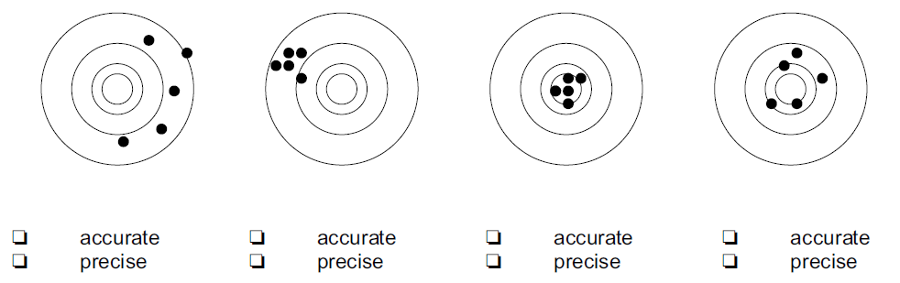

2. The density of copper is measured to be 8650 kg/m3. The accepted value for the density is   
8900 kg/m3. What is the percent error?

3. The accepted value for the acceleration due to gravity is 9.80 m/s2. Two students completed an experiment where they dropped objects from different heights and measured the time it took the objects to fall. Their data is shown below.

|  |  |  |
| --- | --- | --- |
| Trial Number | Richard (m/s2) | Alice (m/s2) |
| 1 | 10.23 | 9.75 |
| 2 | 10.07 | 8.75 |
| 3 | 9.32 | 9.87 |
| 4 | 11.5 | 9.34 |
| 5 | 8.97 | 9.77 |

a) For each student’s data set calculate the:

i. average value

ii. percent difference

iii. percent error (use the average value from (i) for ‘your value’)

b) Which student was more accurate? Justify your response.

c) Which student was more precise? Justify your response.

d) The students used a meter stick and a digital stopwatch. Discuss the possible sources of random and systematic error in this experiment.

4. Compare the value of π to two sets of calculated values: (Set A: 3.14, 3.17, 3.09) and (Set B: 3.21, 3.23, 3.20). Are they accurate? Are they precise? Justify your answers.